IEEE 802.11 Wifi Frame Format

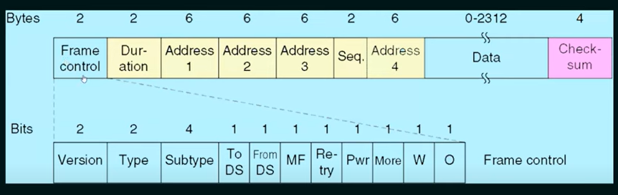

1. Protocol version: The first sub-field is a two bit field set to 00. It has been included to allow future versions of IEEE 802.11 to operate simultaneously.
2. Type: It is a two bit subfield that specifies whether the frame is a data frame, control frame or a management frame.
3. Subtype: It is a four bit subfield states shelter the field is a request to send(RTS) or a clear to send (cts) control frame. For a regular data frame, the value is set to 0000.
4. To DS: A single bit subfield indicating whether the frame is going to the access point(AC), which coordinates the communications in the centralized wireless systems.
5. From DS: A single bit subfield indicating whether the frame is coming from the Acess point
6. More fragments (MF): A single bit subfield which wen set to 1 indicates that more fragments would follow.
7. Retry: A single bit subfield which when set to 1 specifies a retransmission of a previous frame.
8. More data: A single bit subfiled showing that sender has further data frames for the receiver.
9. WEP: A single bit subfield indicating that this is an encrypted frame.
10. Order: The last subfield, of one – bit, informs the receiver that to the higher layer the frames should be in an order sequence.
11. Duration: Specifies the time period for which the frame and its acknowledgement occupy the channel.
12. Address: 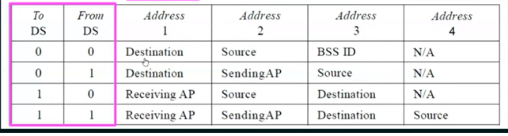
13. Sequence: Stores the frame numbers: It detects duplicate frames and determines the order of frames for higher layers. Among the 16 bits, the first 4 bits provide identification to the fragment and the rest 12 bits contain the sequence number that increments with each transmission.
14. Data: This is a variable sized field that carries the payload from the upper layers. The maximum size of the data field is 2312 bytes.
15. Checksum: For Error detection purpose.